Media Coverage Dr Emma O Brien
Media | Title/Date | Audience
Limerick Post, 20th June 2020 | New Entrepreneurial Education Learning Hub at Mary Immaculate College – Dr Maeve Liston, Dr Emma O’Brien, Patricia O Sullivan Press Release | Est audience, 500
21st Jan 2017, Irish Examiner, | Third Level Urged to Link with Businesses – Dr. Emma O’Brien, press release.  Est audience, 700 | 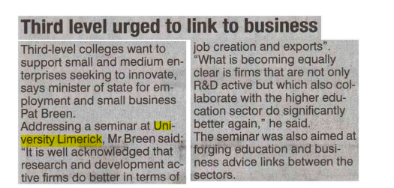
27th Jan 2017, Irish Times: The World of Work Supplement | Making Learning Practical for Small Business Owners – Dr. Emma O’Brien, interviewed.  Est audience, 7000 | 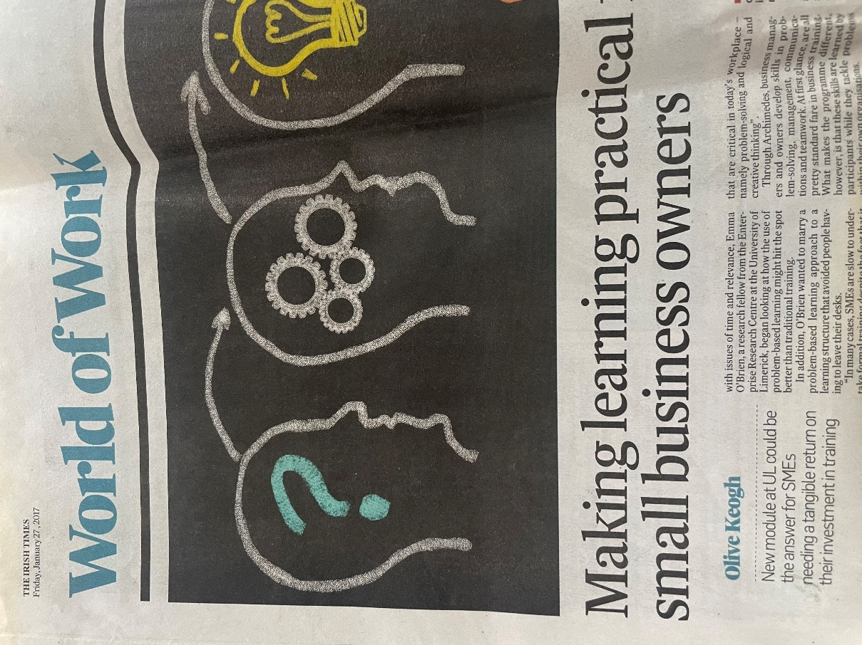
29th Jan 2017, Limerick Leader | UL to Drive Links with SMEs to Boost Jobs – Dr. Emma O’Brien, press release.  Est audience, 500 | 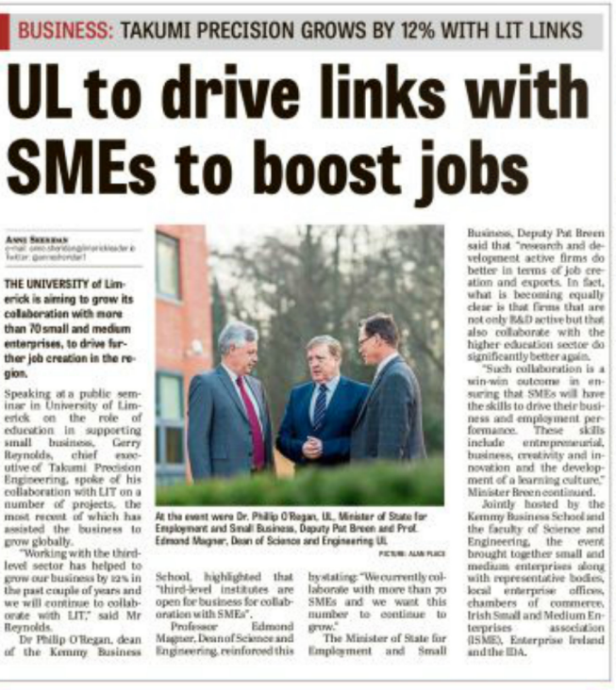
20th Jan 2017, Galway Bay FM, Clare FM, Limerick 95FM and Radio Kerry | Universities and Small and Medium Enterprises to Work Together to Stimulate Ireland's Economy – Dr. Emma O’Brien, interviewed. | Est audience, 7000
Nov 2016 ISME press release | Maximising ROI with PBL launched by minister Pat Breen  Est audience, 1, 200 | 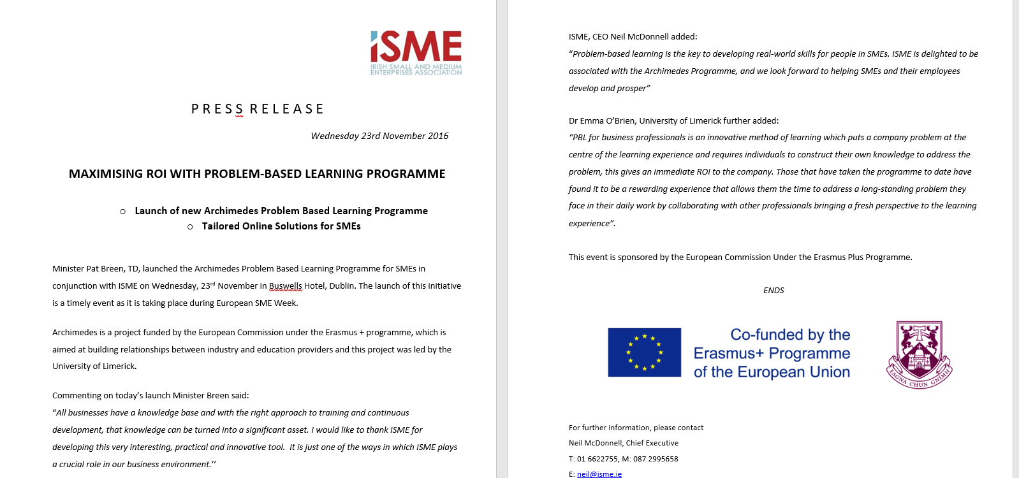
30th July 2011 Limerick leader | Dr Emma O Brien Academic who sees learning as central to personal and business growth  Est audience, 500 | 