Taught MA Theses – MIRR

MA Taught theses from 2023 are available to view in an internal collection on MIRR. We will no longer be receiving theses in print. The collection is only available to MIC staff and students. MIRR can be accessed via the library website:
https://www.mic.ul.ie/library
NB: The theses records are only visible in the collection when logged in via Shibboleth.


- Click on Log in with Shibboleth and enter your MIC username and password.

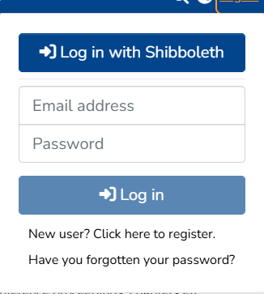

- Scroll down under Communities in MIRR for the Taught Masters Theses (Internal Collection).
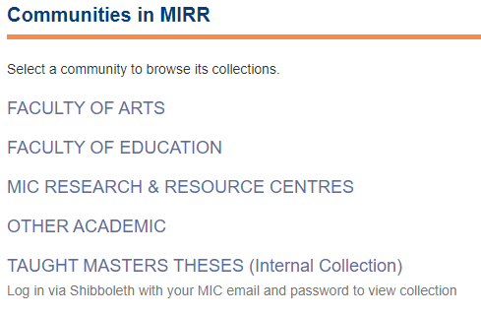
- Click on the course to see the theses in that collection. Click on the required thesis title. Click on files to view document
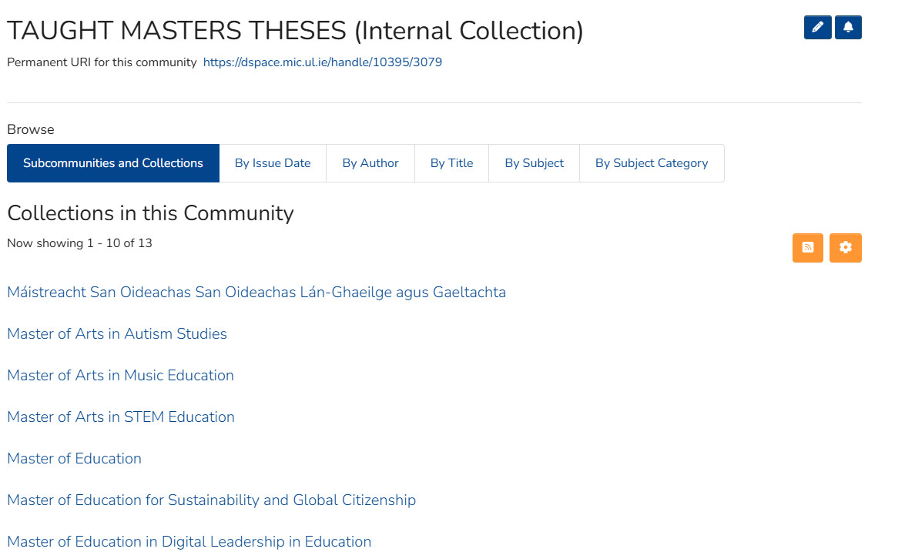
NB: The theses are only visible in the collection when logged in via Shibboleth.

