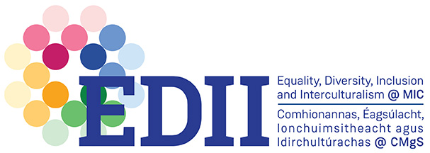

MIC Equality, Diversity, Inclusion & Interculturalism

Project Awards

The aim of the EDII Projects is to catalyse and embed EDII across the College through new collaborative activities. These awards encourage collaboration and partnerships between Professional Service and Academic Staff along with students and community organisations.

Funding, ranging in value from €500 to €5,000 will be awarded in any given academic year. A requirement of accepting the award funding will be to produce a 30 second vignette, outlining the project’s aims and outcomes. You will also be required to acknowledge the MIC EDII Office as a funder of the project in any promotions or publications involving the project.

EDII themes that can be explored include:

- Projects that relate to the AS Institution and Faculty of Arts Actions – click here to access.

- Projects/Activities that relate to the nine grounds of discrimination in Ireland as follows: –
  - Gender: I.E> man, woman or transgender
  - Civil status: includes single, married, separated, divorced, widowed people, civil partners and former civil partners
  - Family status: this refers to the parent of a person under 18 years or the resident primary carer or parent of a person with a disability
  - Sexual orientation: includes gay, lesbian, bisexual and heterosexual
  - Religion: means religious belief, background, outlook or none
  - Age: this does not apply to a person aged under 16
  - Disability: includes people with physical, intellectual, learning, cognitive or emotional disabilities and a range of medical conditions
  - Race: includes race, skin colour, nationality or ethnic origin
  - Membership of the Traveller community.

- Projects and Activities may encompass:
- Research Projects
- Community Engaged Projects
- Curriculum design activities
- Events that promote EDII

MIC Equality, Diversity, Inclusion & Interculturalism

Project Awards

Application for Funding

Title of proposed project:
Applicant Name:
Email:
Phone:
Unit/Department:
Category, please tick: | Research Project  Curriculum Design Activities  Community Engaged Research  Events that promote EDII
Targeting Ground:

(gender, civil status, family status, sexual orientation, disability, religion, age, race, membership of the Traveller community, and socio-economic status, other (please specify))
Summary/ Brief Description:

(please provide further detail by attaching 1 or 2 pages to this application including possible community collaborators and opportunities for an EDII dimension)

Anticipated Outcomes of the Project:
Timeframe and Project Process:
Estimated Total Cost:

Approximate Costs Breakdown:

Scoring Sheet

Title of proposed project:
Relevance to selected themes/EDII grounds (Max 20 points):
Expected benefit (impact) for MIC (Max 30 points)
Expected benefit (impact) for wider society (Max 10 points)
Originality and creative approach (Max 20 points)
Value for money (Max 20 points)

