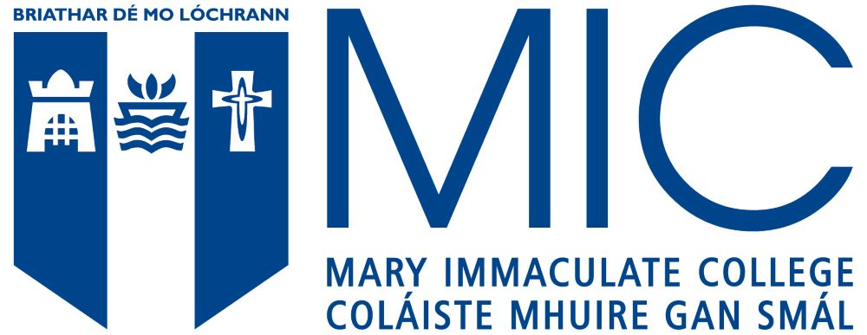

Mary Immaculate College
Employee Reference Form

The purpose of this form is to verify that the applicant was employed, and the nature of the employment. This information is required to support a claim for additional points in gaining entry to the Professional Master of Education in Mary Immaculate College.

The applicant should complete the form in as much detail as possible. On completion and signed, please upload it with your online application form.

The employer should check that the information is accurate, and verify by signing and endorsing with an official stamp.

Applicants name
Applicants address

Employer name
Employer address
Nature of employment
Please be as specific as possible, highlighting how this employment is relevant to your degree and/or to working with young people
Full time or part time | Full time  Part time
Start and end dates | Start ___________________  End ___________________
Was this paid employment? | Yes No

Signed: _____________________ Official Stamp

