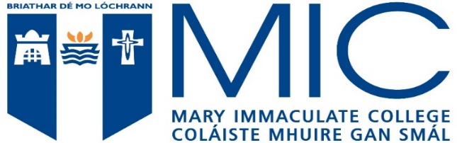

A Level Students Entry Requirements 2022

Applicants should note all of the following requirements for admission to full time Arts Programmes at Mary Immaculate College, and Admission to B.Sc Psychology Programme.

MINIMUM ENTRY REQUIREMENTS
6 distinct recognised subjects which must include: 2 subjects at GCE A Level Grade C and 4 other subjects at GCSE O Level Grade C which must include English, Mathematics and another language.
Entry to undergraduate programmes is competitive, and attainment of the minimum eligibility requirements does not guarantee a place. Qualified candidates to all full-time undergraduate degree programmes, are placed on an order of merit based on a points system.

POINTS TO NOTE

●A-level grades taken over a single sitting may be combined with AS grades from the same year, or 1 year previous.
●AVEC – Do not fulfill minimum and specific subject requirements.
●A maximum of four different recognised subjects, which are not mutually exclusive, will be counted.
●If 4 A-levels are presented, the lowest grade is scored at a lower rate.
●Only A-level grades awarded at the same date can be considered for computation.
●Applicants are scored on the basis of their best four A-levels, or three A-levels and an AS level in a different subject from the same or preceding year (note one A-level grade from the previous year may be substituted for an AS grade, but will only be scored as an AS).
●Grades in the same subject in A2 and AS level cannot be combined.

