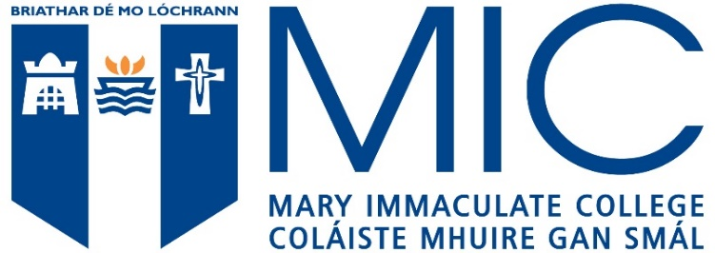

Acceptable English Language qualifications include the following:
MATRICULATION EXAMINATIONS | From European countries where English is presented as a subject and an acceptable level is achieved
IRISH LEAVING CERTIFICATE ENGLISH | Ordinary Level Grade D or above
TOEFL | 580 (paper based) or 90 (internet based)
IELTS | Minimum score of 6.5 with no less than 6.0 in any component.
ETAPP) ENGLISH TEST FOR ACADEMIC AND PROFESSIONAL PURPOSES | Grade C1
GCE ‘O’ LEVEL ENGLISH LANGUAGE/ GCSE ENGLISH LANGUAGE | Grade C or above
UNIVERSITY OF CAMBRIDGE ESOL | Certificate of Proficiency in English - Grade C /  Certificate in Advanced English - Grade B
GCE EXAMINATION BOARDS | Oxford Delegacy of Local Examinations - Grade C / Cambridge Local Examinations Syndicate - School Certificate Pass 1-6 /  University of London Entrance and School Examinations Council - School Certificate Pass 1-6
PEARSON TEST OF ENGLISH (ACADEMIC) - PTE ACADEMIC: | a minimum score of 61 (with no section score below 59)
OXFORD ENGLISH TEST | Overall minimum 140. Individual skills 125

