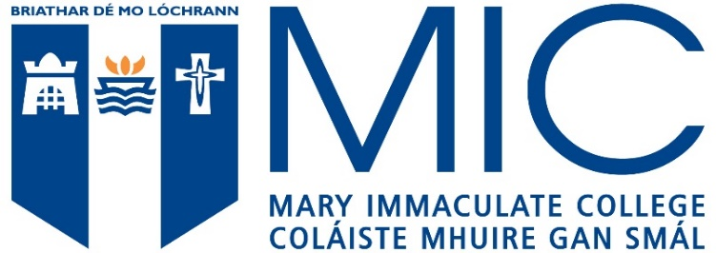

Acceptable English Language qualifications include the following:
MATRICULATION EXAMINATIONS | From European countries where English is presented as a subject and an acceptable level is achieved
IRISH LEAVING CERTIFICATE ENGLISH | Ordinary Level Grade D or above
TOEFL | 580 (paper based) or 90 (internet based)
IELTS | Minimum score of 6.5 with no less than 6.0 in any component.
ETAPP) ENGLISH TEST FOR ACADEMIC AND PROFESSIONAL PURPOSES | Grade C1
GCE ‘O’ LEVEL ENGLISH LANGUAGE/ GCSE ENGLISH LANGUAGE | Grade C or above
UNIVERSITY OF CAMBRIDGE ESOL | Certificate of Proficiency in English - Grade C or  Certificate in Advanced English - Grade B
GCE EXAMINATION BOARDS | Oxford Delegacy of Local Examinations - Grade C / Cambridge Local Examinations Syndicate - School Certificate Pass 1-6 /  University of London Entrance and School Examinations Council - School Certificate Pass 1-6
PEARSON TEST OF ENGLISH (ACADEMIC) - PTE ACADEMIC: | a minimum score of 61 (with no section score below 59)
OXFORD ENGLISH TEST | Overall minimum 140. Individual skills 125.
LANGUAGE CERT ESOL | B2 Communicator High Pass with no less than 33 in each skill.
DUOLINGO ENGLISH TEST (DET) | The minimum requirement will be a DET score of 120 with at least 110 in each sub score. This test of English will be accepted for 2022 and 2023 (it may not be recognised in 2024). An interview may be required in addition to this.

European Union applicants must apply to Mary Immaculate College via the Central Applications Office (CAO).

