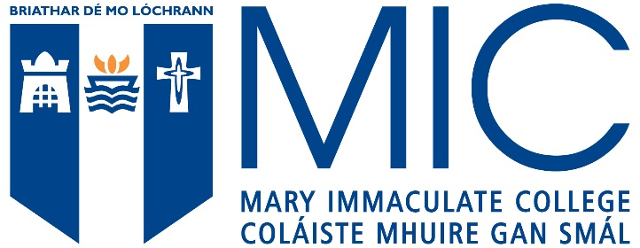

Getting to MIC: Travel Information

Driving
Visitor parking is best accessed by car from the Courtbrack Avenue entrance to Mary Immaculate College (as if going to the Lime Tree Theatre); there is a mix of free and paid-for parking.

Once you have entered, follow the road and tree-lined avenue and the first two carparks are on the left (although accessed by going through a barrier, they are free). If you pass these car parks, the road leads around to a roundabout; the large imposing building to the right is TARA. Off the roundabout, there is another large carpark (free on weekends; paid-for on weekdays—€3 a day flat fee).

Visitors are advised not to enter via MIC’s main entrance on the South Circular Road because there is a staff carpark directly ahead (only open to visitors on weekends) and a limited number of reserved spaces.

Do not park in the bus parking spaces or set-down areas outside the TARA and Tailteann buildings. Do not park in the disabled parking area directly in front of Summerville House or any other spots designated as such unless you have a valid Disabled Driver/Passenger Permit. Do not park in spaces reserved for staff or named visitors. Clamping is in operation on campus if cars are parked illegally.

On-Street Parking
There is on-street parking surrounding the College on O’Connell Avenue, Summerville Avenue, the South Circular Road, Courtbrack Avenue, New Street and Henry Street. Most of this is 2-hour disc parking but closer the city may be 1 hour. With some areas, it is only necessary to put a disc up Monday to Friday and there will be signs outlining the requirements on individual streets.

Discs can be purchased in most local shops and you can use them one at a time only (e.g. putting up two discs to cover a 4 hr period is not allowed). When the 2 hour period passes and your disc times out, a traffic warden may give a parking fine. Limerick City Council also offers an e-parking service (http://www.limerickparking.ie) by using the website, calling a local phone number or by downloading a smartphone App. This allows you to secure and extend your parking remotely without physically changing discs.

Nearby Car Parks
The Clayton Hotel, Steamboat Quay (formerly the Clarion) has a Euro Car Park 15 metres from the front door so after taking the turn off for the entrance from either direction, the car park is on the right. Also, if you continue past the hotel entrance, there is a limited amount of Pay and Display parking here. www.eurocarparks.ie, 01-8908320.
Q-Park Henry Street (address is Mount Kennett) is another nearby option: http://www.q-park.ie, 061-405868.

In both these cases, there is 15-20 minute walk to MIC—either by continuing along the Dock Road or along upper Henry Street and turning off as needed.

There is also a Q-Park multi-storey at Harvey’s Quay behind a large branch of Dunnes Stores (061-468240) but that is a significant walk of 20-30 minutes to MIC, straight up Henry Street.

Bus Routes
Two main bus services stop in the vicinity of MIC.

With the 304 service (University of Limerick to Ballycummin), you can get on at the University of Limerick, Stables Bar or in the City Centre at Sarsfield Street, for example, and the relevant stop is at the Carmel House on O’Connell Avenue (or the next stop at Punches Cross). From there, you will see a sign across the road for the MIC John Henry Newman Campus; you can walk through this campus until you reach the main gates of MIC Limerick on the South Circular Road. If you get off at Punches Cross, cross the road and continue straight down New Street. At the roundabout near Fennessy’s Pub, turn right to get to the main gates.

The 304A service (see details below under Colbert Station) allows you to get on at UL, the station or if coming in the opposite direction, at numerous stops in Raheen or opposite the St Nessan’s Road entrance to the Crescent Shopping Centre in Dooradoyle.

Other options

Crescent Shopping Centre
There are 1,500 free parking spaces here.

On Foot
MIC is around 15-20 minutes’ brisk walk from the centre. Exiting from the St Nessan’s Road entrance, cross the road and walk right, branch off left to the South Circular Road (there is a slipway here branching from the main Ballinacurra Road) and continue straight. When you arrive at Fennessy’s Bar (which will be on your right), continue straight and cross the road. If you continue straight, MIC will be on the left.

By Bus
There are bus stops for the 304A service at several locations in Raheen and Dooradoyle, and that stops at Punches Cross (see directions for 304 above) and Egleston Photography on O’Connell Avenue. If you alight there, go right and turn right. At the Redemptorist Church, go left and a few minutes’ later, you’ll arrive at MIC.

Colbert Train & Bus Station
The station offers all day parking for a reasonable fee.

By Bus
The 304A service (University of Limerick to Raheen) picks up at Hyde Road Post Office (standing at the station facing out, go left to find it). You can get off at the Model School in O’Connell Avenue, cross the road, turn right and take an immediate left towards the Redemptorist Church, go left and a few minutes’ later, you’ll arrive at MIC. You could also alight at the next stop, Carmel House, on O’Connell Avenue. On the right, you will see a sign for the MIC John Henry Newman Campus; you can walk through this campus until you reach the main gates of MIC Limerick on the South Circular Road.
On Foot
The station is around 15-20 minutes’ brisk walk from MIC. Cross the road to People’s Park, from there follow the railings along the left perimeter towards Edward Street (a green area with some parking spaces will be opposite), continue walking and take the second right for Wolfe Tone Street. Follow the street to the end and then cross the road, taking the street directly ahead (Gerard Street). At the end of this street, turn left onto the South Circular Road and continue straight. Pass the Redemptorist Church and a few minutes’ later, you’ll arrive at MIC.

Further information: http://www.irishrail.ie/travel-information/limerick-colbert

