Taught MA Theses – MIRR

MA Taught theses from 2023 are available to view in an internal collection on MIRR. We will no longer be receiving theses in print. The collection is only available to MIC staff and students. MIRR can be accessed via the library website:
https://www.mic.ul.ie/library

Log in is via Shibboleth using their MIC username and password.
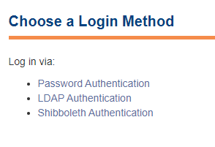
Scroll down under Communities in MIRR for the Taught Masters Theses (Internal Collection).
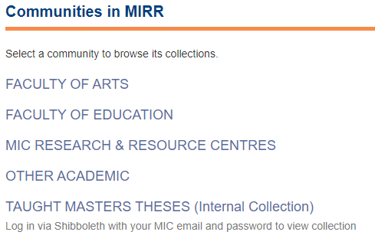
The collection is broken down by MA courses. Click on the course and click on the theses to view. It can then be viewed online or downloaded.
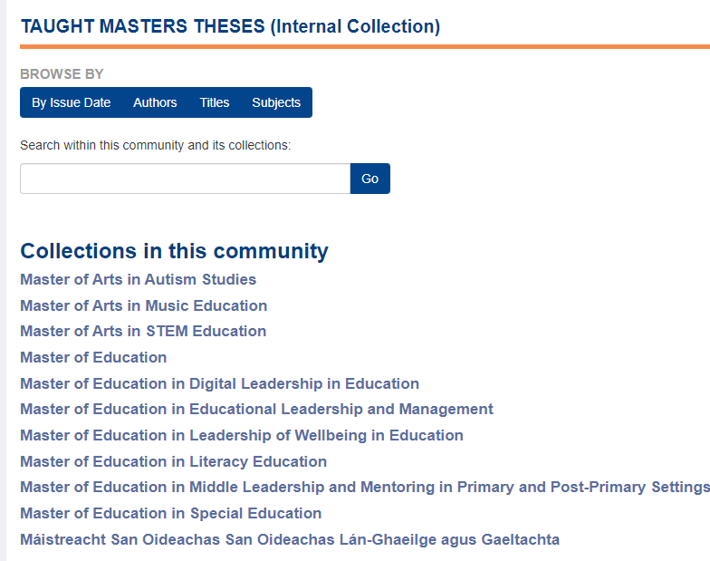
NB: The theses are only visible in the collection when signed in.

